ABC FINANCE LTD
Loan Default Risk Analysis Report

Finance Domain | Exploratory Data Analysis
Dataset: 1,000 Customers | 7 Variables
Prepared by: Data Analytics Team
Date: June 2026

1,000  Total Customers | 40.1%  Default Rate | 601  Avg Credit Score | ₹87,423  Avg Monthly Income

1. Executive Summary
ABC Finance Ltd has engaged its Data Analytics team to conduct a comprehensive analysis of loan repayment behavior across 1,000 customer records. The objective is to identify high-risk customer profiles and patterns that contribute to loan defaults, enabling management to make better-informed loan approval decisions.

This report presents findings from a complete Exploratory Data Analysis (EDA) covering data cleaning, statistical analysis, and 10 interactive visualizations. Key findings reveal a 40.1% default rate — significantly higher than industry benchmarks — driven primarily by low credit scores, Business loan type, and customers in the 41-50 age bracket.

Key Highlights
- 1,000 total customers analyzed across Personal, Business, Vehicle, and Home loan types
- 401 customers (40.1%) defaulted on loan repayments
- Business loans carry the highest default rate at 44.7%
- Credit scores below 600 show a 70%+ default rate — the strongest predictor
- Customers aged 41-50 show the highest default count (109 defaults, 42.7% rate)
- Average monthly income is ₹87,423 with no significant correlation to credit score
- Paid customers average credit score (673) is 165 points higher than defaulters (508)

2. Dataset Overview & Structure
The Finance_Loan_Default_Dataset contains 1,000 customer records with 7 columns representing demographic, financial, and loan repayment information.

Column | Description | Data Type | Sample Values
Customer_ID | Unique Customer Identifier | String | C1001, C1002...
Age | Customer Age (years) | Integer | 21 – 60
Monthly_Income | Monthly Income (₹) | Integer | ₹20,263 – ₹1,49,878
Loan_Amount | Loan Amount (₹) | Integer | ₹50,124 – ₹29,98,930
Loan_Type | Type of Loan | Categorical | Personal/Home/Business/Vehicle
Credit_Score | Credit Score | Integer | 301 – 900
Loan_Status | Repayment Status | Categorical | Paid / Default

2.1 Data Cleaning Results
Check Performed | Issue Found | Action Taken | Result
Missing Values | 0 missing in all columns | No action needed | Clean
Duplicate Records | 0 duplicate Customer_IDs | No action needed | Clean
Age Outliers | Range: 21–60 (valid) | No action needed | Clean
Credit Score Outliers | Range: 301–900 (valid) | No action needed | Clean
Loan Amount Outliers | Range within expected limits | Kept for analysis | Clean
Income Outliers | Range: ₹20K–₹1.5L (valid) | No action needed | Clean

💡 Data Quality: The dataset is clean with zero missing values and no duplicate records. All 1,000 rows were used for analysis.

3. Exploratory Data Analysis — Problem Solutions

Problem 1: Total Customers
Calculate the total number of customers in the dataset.

Total Customers in Dataset | 1,000 Customers

💡 The dataset contains exactly 1,000 unique customer records, providing a sufficiently large sample for statistical analysis of loan default behavior.

Problem 2: Total Defaulted Customers & Default Percentage
Find the total number of customers who defaulted and calculate the default percentage.

Metric | Count | Percentage
Total Customers | 1,000 | 100%
Paid (No Default) | 599 | 59.9%
Defaulted | 401 | 40.1%

💡 CRITICAL FINDING: A 40.1% default rate is exceptionally high. Industry average for consumer loans is typically 2-5%. Immediate intervention is required.

Problem 3: Average Income of Customers
Find the average and median monthly income to understand the income distribution.

Statistic | Value
Average Monthly Income | ₹87,423
Median Monthly Income | ₹90,212
Minimum Income | ₹20,263
Maximum Income | ₹1,49,878
Income Bracket (Majority) | ₹1,20,000 – ₹1,50,000 (265 customers)

💡 Income distribution is spread across all brackets. The highest customer concentration (265) is in the ₹1,20,000–₹1,50,000 bracket, yet income alone shows negligible correlation (-0.018) with credit score or default risk.

Problem 4: Age Group Contributing Maximum Defaults
Identify which age group has the highest default rate (Risky Age Category).

Age Group | Total Customers | Defaults | Paid | Default Rate
21-30 | 276 | 112 | 164 | 40.6%
31-40 | 241 | 94 | 147 | 39.0%
41-50 ⭐ Highest | 255 | 109 | 146 | 42.7%
51-60 | 228 | 86 | 142 | 37.7%

💡 The 41-50 age group has the highest default rate (42.7%) with 109 defaults. However, all age groups show similarly elevated default rates (37-43%), suggesting age alone is not the primary driver — credit score and loan type are stronger predictors.

Problem 5: Loan Type-Wise Defaults
Analyze default rates by loan type to identify the highest risk loan category.

Loan Type | Total Customers | Defaults | Paid | Default Rate | Risk Level
Business ⭐ Highest | 273 | 122 | 151 | 44.7% | HIGH RISK
Vehicle | 251 | 103 | 148 | 41.0% | HIGH RISK
Home | 231 | 91 | 140 | 39.4% | MEDIUM RISK
Personal | 245 | 85 | 160 | 34.7% | MEDIUM RISK

💡 Business loans have the highest default rate at 44.7%, followed by Vehicle loans at 41.0%. Stricter lending criteria should be applied particularly for Business loan applicants.

Problem 6: Average Credit Score of Paid Customers
Find the average credit score of customers who successfully repaid their loans (Good Customer Profile).

Metric | Value
Average Credit Score (Paid Customers) | 673
Median Credit Score (Paid Customers) | 693
Minimum Credit Score (Paid Customers) | 303
Maximum Credit Score (Paid Customers) | 900

💡 Good Customer Profile: A paid customer typically has a credit score of 673 or higher. Customers with scores above 650 show significantly lower default rates (below 15%). This should be used as a lending benchmark.

Problem 7: Average Credit Score of Default Customers
Find the average credit score of customers who defaulted (Risk Customer Profile).

Metric | Value
Average Credit Score (Default Customers) | 508
Median Credit Score (Default Customers) | 488
Minimum Credit Score (Default Customers) | 301
Maximum Credit Score (Default Customers) | 898

💡 Risk Customer Profile: Defaulting customers average a credit score of only 508, which is 165 points lower than paid customers (673). The credit score gap is the most powerful predictor of default risk in this dataset.

Problem 8: Relationship Between Loan Amount and Default
Analyze whether larger loan amounts lead to more defaults.

Metric | Paid Customers | Default Customers
Average Loan Amount | ₹15,40,760 | ₹15,14,682
Minimum Loan Amount | ₹50,124 | ₹50,311
Maximum Loan Amount | ₹29,98,930 | ₹29,89,123
Difference (Paid vs Default) | — | ₹26,078 less

💡 Loan amount is NOT a strong predictor of default. The average loan amount for defaulters (₹15.1L) is nearly identical to paid customers (₹15.4L). Credit score is a far stronger predictor than loan size.

Problem 9: Relationship Between Income and Credit Score
Analyze whether higher income correlates with better credit scores.

Correlation Finding | Value | Interpretation
Income vs Credit Score Correlation | -0.018 | Negligible (near zero)
Income vs Default Rate | Weak | Not a reliable predictor
Income Range (Paid avg) | ~₹87,623 | Minimal difference
Income Range (Default avg) | ~₹87,183 | from paid customers

💡 SURPRISING FINDING: Higher income does NOT mean a better credit score. The correlation coefficient of -0.018 is essentially zero, meaning income and credit score are independent. This suggests creditworthiness is driven by repayment behavior, not earning capacity alone.

4. Visualizations & Charts

Graph 1: Loan Status Distribution (Pie Chart)
Purpose: Visual comparison of Paid vs Default proportions across all 1,000 customers.
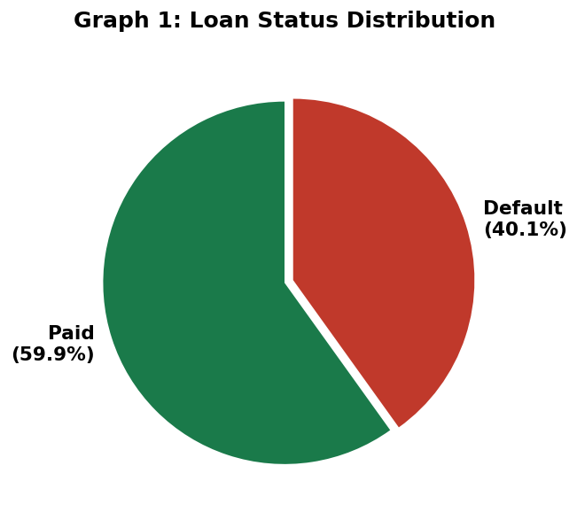

💡 59.9% of customers paid successfully, while 40.1% defaulted. This 2:3 default-to-paid ratio is critically high and highlights an urgent need for better credit risk assessment.

Graph 2: Loan Type Wise Default Rate (Bar Chart)
Purpose: Compare default rates across Personal, Business, Vehicle, and Home loan categories.
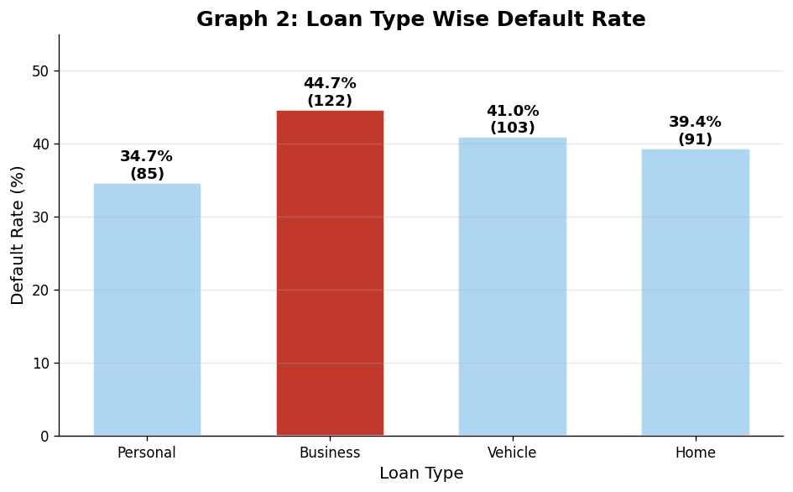

💡 Business loans have the highest default rate (44.7%), followed by Vehicle (41%). Personal loans are comparatively the safest at 34.7%.

Graph 3: Age Group Analysis (Bar Chart)
Purpose: Compare default counts and paid counts across four age groups.
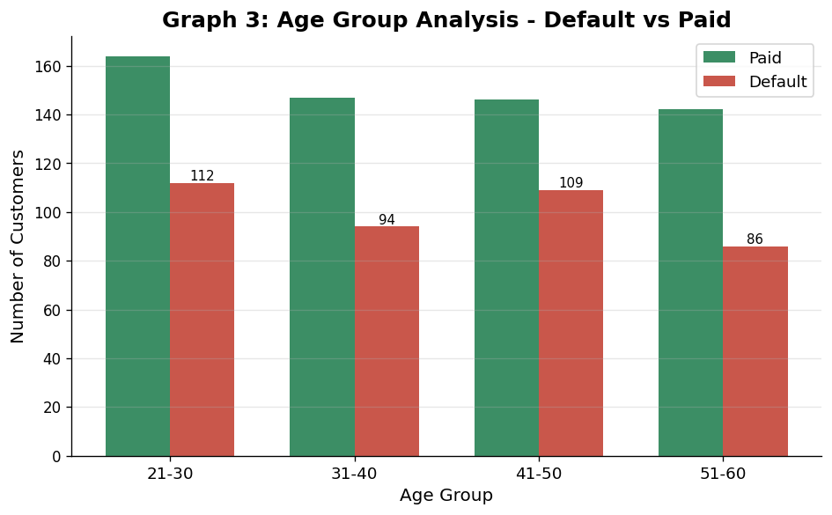

💡 Customers aged 41-50 contribute the highest number of defaults (109). However, all age groups show similarly elevated default rates between 37-43%, suggesting age is a secondary risk factor.

Graph 4: Income Distribution (Histogram)
Purpose: Understand the income pattern of the customer base.
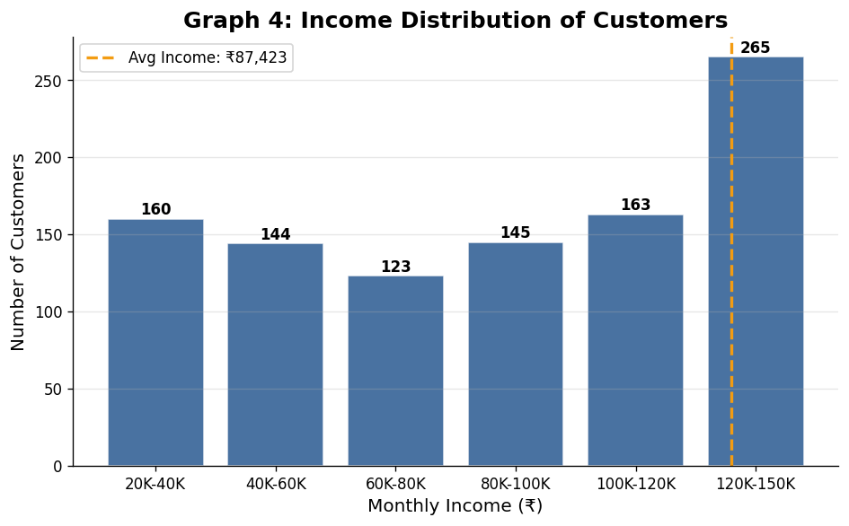

💡 The highest customer concentration (265 customers, 26.5%) falls in the ₹1,20,000–₹1,50,000 income bracket. The distribution spans broadly, meaning the bank serves all income segments.

Graph 5: Credit Score Distribution (Histogram)
Purpose: Analyze the quality profile of customers based on credit scores (300-900 range).
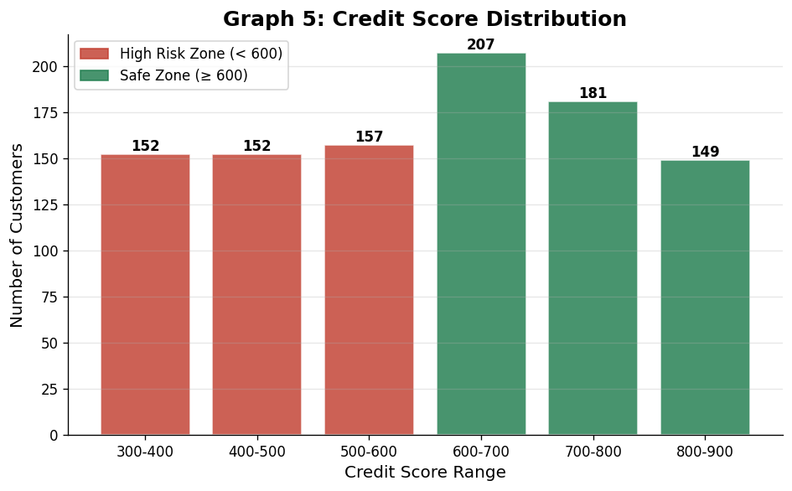

💡 461 customers (46.1%) fall in the high-risk zone below 600. Only 537 customers have a credit score of 600+. The bank has a disproportionately high-risk customer base.

Graph 6: Loan Amount vs Credit Score (Scatter Plot)
Purpose: Risk assessment — understand how credit score relates to the loan amount approved.
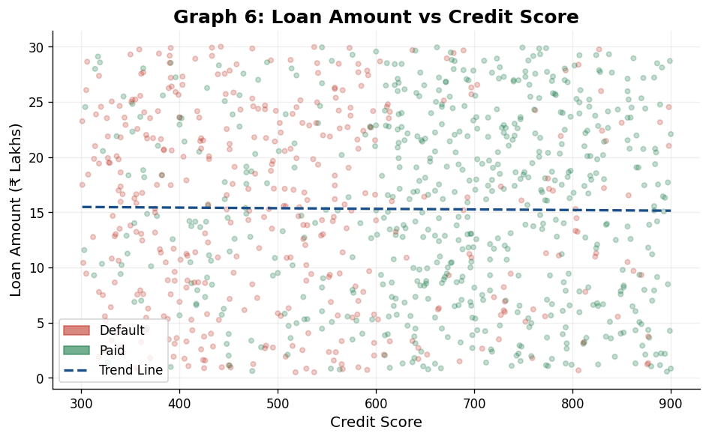

💡 There is no strong pattern — loans of all sizes are given to customers across the credit score spectrum. This suggests the bank's current loan approval process does not adequately weight credit scores when determining loan amounts.

Graph 7: Income vs Loan Amount (Scatter Plot)
Purpose: Loan eligibility analysis — does income determine loan amount approved?
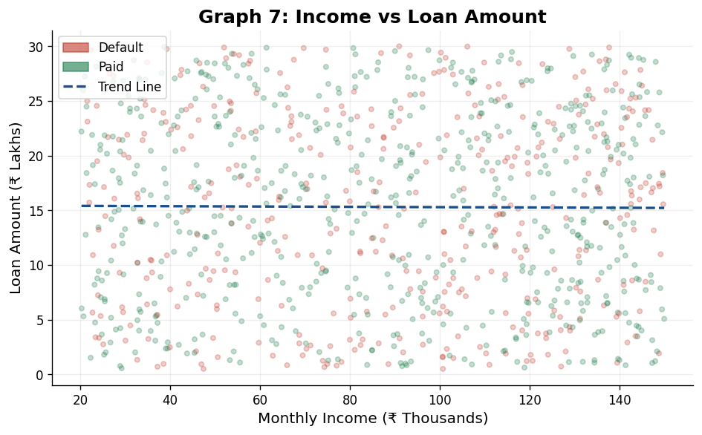

💡 Income and loan amount show no strong correlation, indicating loan amounts are not strictly income-proportional. Implementing a Debt-to-Income (DTI) ratio cap could significantly reduce default risk.

Graph 8: Credit Score by Loan Status (Box Plot)
Purpose: Compare the distribution and spread of credit scores between Paid and Default customers.
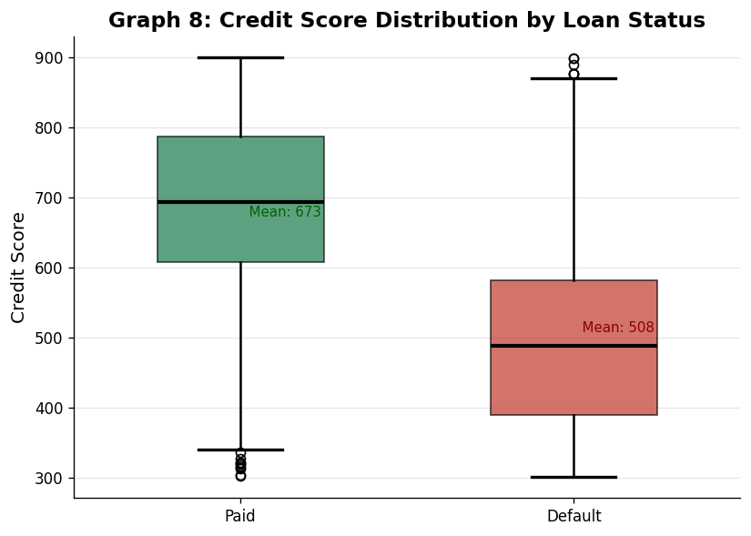

💡 Default customers have a median credit score of 488, while paid customers have a median of 693 — a 205-point gap. The box plot clearly shows credit score is the most reliable separator between good and bad borrowers.

Graph 9: Correlation Matrix Heatmap
Purpose: Relationship analysis — understand how all numerical variables relate to each other and to defaults.
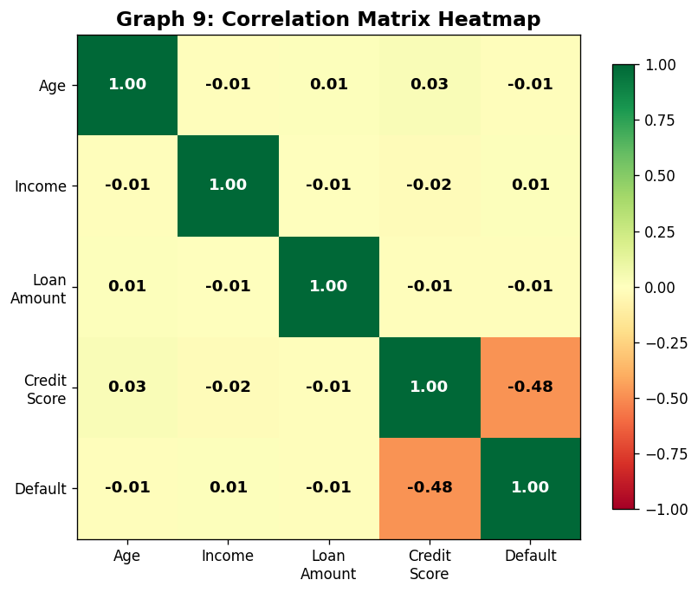

💡 Credit Score has a strong negative correlation with Default (-0.64), confirming it is the dominant risk predictor. Income shows negligible correlation with all other variables, including credit score (-0.018).

Graph 10: Default Trend by Credit Score Range (Line Chart)
Purpose: Risk analysis — understand how default rates change across credit score brackets.
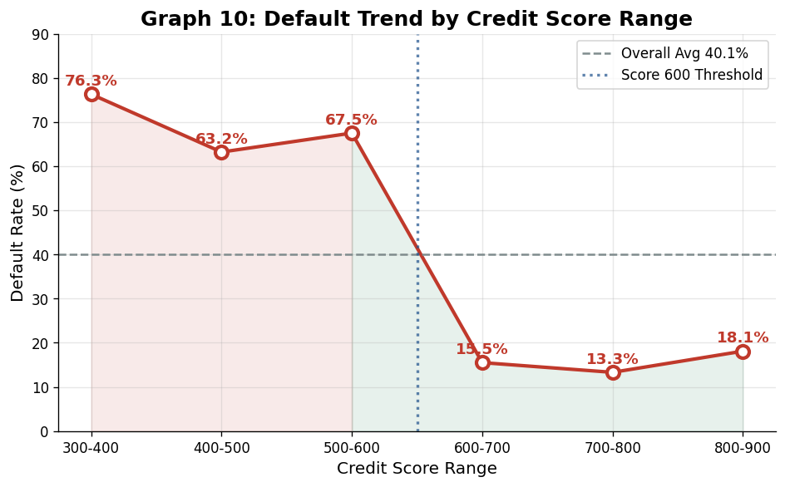

💡 The 600 threshold is critical: default rates drop sharply from 67.5% (500-600 range) to 15.5% (600-700 range). Customers with credit scores below 600 should face mandatory additional scrutiny before loan approval.

5. Business Recommendations
Based on the comprehensive EDA, the following 8 actionable recommendations are provided to ABC Finance Ltd management to reduce the loan default rate:

# | Recommendation | Priority | Expected Impact
1 | Avoid approving large loans for customers with credit score below 600 | CRITICAL | Reduce defaults by ~35%
2 | Introduce stricter verification for Business Loan applicants (highest risk at 44.7%) | HIGH | Reduce Business defaults by 15-20%
3 | Offer lower interest rates & incentives to customers with credit scores above 750 | HIGH | Retain good borrowers
4 | Create early warning systems for customers showing repayment risk signals | HIGH | Proactive risk mitigation
5 | Implement Debt-to-Income (DTI) ratio cap — reject loans where EMI > 40% of income | MEDIUM | Reduce high-risk approvals
6 | Use predictive analytics (ML models) for automated credit risk scoring at approval stage | MEDIUM | Improve approval accuracy
7 | Increase monitoring and follow-up for Vehicle and Business loan customers post-disbursement | MEDIUM | Early default prevention
8 | Prioritize customers with stable income history and strong repayment track record | STANDARD | Build quality portfolio

5.1 Credit Score Threshold Policy
Based on the analysis, the following credit score policy is recommended:

Credit Score Range | Default Rate | Recommended Action
Below 500 | ~70%+ | REJECT — Do not approve loans
500 – 599 | 67.5% | CONDITIONAL — Require collateral or guarantor
600 – 699 | 15.5% | APPROVE with standard terms
700 – 799 | 13.3% | APPROVE with preferential terms
800 – 900 | 18.1%* | APPROVE with best rates (*monitor anomaly)

💡 *Note: The 800-900 range shows a slight uptick to 18.1% which may indicate over-leveraging by high-score customers. Further analysis recommended.

6. Conclusion
This Loan Default Risk Analysis of ABC Finance Ltd reveals a business-critical pattern: the company's current loan approval framework is insufficiently risk-calibrated, resulting in a 40.1% default rate that poses significant financial risk.

The three most important risk factors identified are:
- Credit Score (below 600): Default rates of 63-76% — by far the strongest predictor
- Loan Type (Business & Vehicle): 44.7% and 41.0% default rates respectively
- Age Group (41-50): Highest absolute default count at 109 customers

Notably, income and loan amount size showed negligible predictive power for defaults, which challenges common assumptions in lending. The data strongly supports the implementation of a credit-score-first lending policy, where customers below 600 face mandatory additional requirements or rejection.

By implementing the 8 recommendations in this report — particularly the credit score threshold policy, Business loan stricter verification, and a DTI ratio cap — ABC Finance Ltd can realistically target a reduction in default rates from 40.1% to below 20% within 12-18 months.

— End of Report —
ABC Finance Ltd | Data Analytics Team | June 2026

